**CS691 - Computer Science, Spring 2021**

**Project Initiation Document**

Project: Service General

Project Manager: Harrison Yang

Start Date: 1/26/2021

Completion Date:5/11/2021

Table of Contents

Document Purpose 4

Background to the Proposed Work 4

Vision 5

Project Objectives 5

Project Scope 6

Business Case 6

Assumptions 7

Constraints 8

Risk Management Strategy 9

Deliverables 10

Stakeholders 11

Project Team 12

Project Plan 13

Project Controls 14

Communication Plan 15

Document Details

|  |  |  |  |
| --- | --- | --- | --- |
| Version | Modifications | Author | Date |
| 1. | Initial PID Document |  |  |
|  |  |  |  |
|  |  |  |  |
|  |  |  |  |

Approvals

This document requires the following approvals:

|  |  |  |  |  |
| --- | --- | --- | --- | --- |
| Name | Role | Signature | Date | Version |
| Harrison Yang | Project Manager | x | 2/9/2021 | 1 |
| Darshan Venkata | Product Owner | x | 2/9/2021 | 1 |
| Shaina Sunesara | Lead Business Analyst | x | 2/9/2021 | 1 |
| Melba Louis Moro | Lead Developer | x | 2/9/2021 | 1 |
| Artsiom Naslednikau | DBA | x | 2/9/2021 | 1 |
| TBD | QA Analyst |  | 2/9/2021 | 1 |
| Tanvi Joshi | Tester | x | 2/9/2021 | 1 |

Distribution

This document has been distributed to:

|  |  |  |  |
| --- | --- | --- | --- |
| Name | Role | Date of Issue | Version |
|  |  |  |  |
|  |  |  |  |
|  |  |  |  |
|  |  |  |  |
|  |  |  |  |
|  |  |  |  |

# Document Purpose

This document is the Project Initiation Document (PID) for the *Service General* web application project.

This PID is to define the project and its development. We will communicate the scope, objectives, tasks, roles and responsibilities, costs and deliverables that are required for the Service General web application

* A summary and outline of the approach for the implementation of Service General.
* Details of the roles, responsibilities, functions, features, and activities that are required
* Details of the business process, constraints, benefits of the product, and outcomes together with the impact they will have on the business
* Quality record, risk, project controls and exceptions

This PID will also act as a means of communicating key aspects of the project to Stakeholder of the Service General Web Application. This PID will be the outline of how the success of Service General is measured

# Background to the Proposed Work

Due to COVID-19 the economy has lagged and the unemployment rate has skyrocketed. Many people have turned to alternative means to get a paycheck. One of these ways are freelance jobs or contract jobs. These jobs focus on specialized skills with short to long duration time with high quality of work or service. This is a part of the gig economy. With a total of 55 million people making up 34 percent of the US economy. In 2020, we saw a 43% increase in the gig economy. With this many available workers and eager businesses wanting to take advantage of the specialization that freelancers offer, there is a big demand to create an effective means of communication, facilitation, and management between these two parties. This is what Service General aims to do and what issues we plan to address:

* Current popular apps act as middlemen between the parties with the freelancer having set prices. For Service General our aim is to facilitate a relationship between the freelancer and the client. Having prices be negotiable.
* Current popular apps also use only a zip code as just the metric for distance while Service General aims to be more precise using radius distance from your location to find the nearest freelancer with the best rating.

This project will address the above issues by providing a new sleek designed platform to best communication between client and freelancer.

# Vision

The goal of Service General is to provide excellent communication and relationship building between clients and their freelancer and vice versa. The application will provide features that are easy to use such as an intuitive search by keyword, rating reviews and resources to make sure all users find their opportunity.

# Project Objectives

RELEASE 1 - WEBSITE demo and basic implementation. Feature oriented design.

RELEASE 2 - BUILDING A FULLY FUNCTIONAL AND PROFESSIONAL WEBSITE  
- Search engine, that connects keywords and displays search results.  
- Design Client portal, the part of the website responsible to store and hold information for a registered individual who is required to perform a particular task of their expertise.  
- Design a User portal where any individual who needs a task to be done can have an account to find people to work for them.  
- Use a secure payment gateway for conducting safe and reliable transactions  
- A verification and security check for the Clients are a must.

RELEASE 3 - BUILDING AN EASY TO USE MOBILE APPLICATION  
- There could be 2 separate applications if it were easier to use, an application for the clients and another for users so information does not get cluttered.  
- All search results should be optimized to use prediction in such a way that it filters out the unnecessary words from being predicted.  
- The application can use Google maps to pinpoint the location of the Client as they are approaching for the job.  
- Must be linked to a calendar and reminder system so appointments could be scheduled in advance before the current date.  
- Partnering up and integration with secure payment applications like PayPal, Google Pay would be fruitful as they are fast, reliable and accessible by everyone.  
- Host focus groups to release timely updates and see what features could benefit us.

# Project Scope

This project shall be aesthetic to make the users feel like they have used a similar application before. The design at the user end shall have no more than 2 pages. The search engine is the primary way the user communicates with the application. Hash tags can be used to make searches more precise and concise. This project provides a link between a client and a user for services so security shall be the top priority. Multiple surveys need to be considered to set a norm with regard to pricing as different professionals have different prices. A client could be provided a separate space that is highlighted to attract more users towards their portfolio to increase awareness and revenue. The phase 1 of the project scope is to set a standard database for the application where it can be linked to multiple portfolios and is very pleasing to the eye. Setting up a payment portal is the only way to create monetary value for the project. As the project progresses further, the fine tuning of the project shall be taken care of at that stage.

# Business Case

Business case information can be structured by completing the table below.

|  |  |
| --- | --- |
| **Application Name** | Service General |
| **Type of business model** | Brokerage |
| **Target audience of external users**  **(Customer Segments)** | We’re creating value to the people in need of a particular task done by connecting them with an individual who is willing to complete this task for some payment. |
| **Groups of internal stakeholders, business users** | Development team, Marketing Team, customer support |
| **Value propositions** | What value do we deliver to the customer?   * The satisfaction of hiring help at their finger tips.   Which one of our customer’s problems are we helping to solve?   * We’re helping both the employer and the beneficiary also being the employed individual.   What bundles of products and services are we offering to each Customer Segment?   * Skill and talent based services.   Which customer needs are we satisfying?   * General population. |
| **Key resources** | What Key Resources do our Value Propositions require?  Our Distribution Channels?  Customer Relationships?  Revenue Streams? |
| **How the system is used** | If I require a task or a service to be done by someone else who is an expert in that field (Tattoo artist, Plumber, Cook) I log on to the web application and search for the service that is required by me. Once I find a suitable candidate for my job. I place a bid for how much I am willing to pay. He either accepts the offer or sends in a counter. On completion of the task both employer and employee agree and confirm to the payment. |
| **Revenue generation, Revenue streams** | Once the transaction is successful we would levy a 10% charge for being the broker in the middle. |
| **Key Partners/Suppliers**  **(Stakeholders)** | Regular people, restaurants, bars, people in need of work |
| **Expected Benefits** |  |
| **Known Prototypes** | [www.jungleworks.com](http://www.jungleworks.com) , [www.urbancompany.com](http://www.urbancompany.com) |
|  |  |

# Assumptions

The assumptions supporting the Project are:

• Cloud server will be provided for hosting this web application.

• licensing for persistence layer will be provided.

• A test server will be provided for debugging the application issues.

• Above servers will contain all the required software packages needed by the web application.

• A private GitHub Repo will be provided for maintaining the code base of this application.

• Project manager will conduct a weekly meeting for listing out the task to be completed in that particular week.

• BA and QA will right all the test cases for the task listed.

• Project manager will assign the task to the team members.

• Team members will spend at least 3 hours daily on the assigned task.

• Individual task owners will send merge request to Lead Developer.

• Lead Developer will provide comments for code improvisation and merge the pull request.

• Team members will deploy the updated code on the webserver every week.

# Constraints

**Constraints**

The aspects that need to be taken into consideration during the delivery of the project are:

• Storage space

-> cannot add dynamic storage space as storage space is fixed.

• Data backup and Restoration.

-> Backup will be taken every midnight.

-> If database gets corrupted.

-> Data will be restoring from previous backup taken at midnight.

• Application logs

-> Last 30 days logs will be stored and previous logs will be deleted for avoiding space overflow.

• Maintenance and service General Customer care

-> Maintenance and Customer care will be provided during EST hours.

• Location Dependency

-> Some services might not be available if there are no service providers at the given location.

• Project team members availability

-> The team members of this project have other courses to attend thus cannot provide 100% availability.

• Users of the web application should be an adult and above 18 years of age.

# Risk Management Strategy

Risk management is basically an approach in which we explore, identify, analyze and mitigate the risks that can affect our project. Risk management is an important part of project management which if done efficiently leads to the success of your project. Risk management is an action plan that consists of various steps which are done to ensure the removal of risk

**Risk Analysis**

* **Risk Identification:** Identify the risks within the project, and that you'll either need to manage or accept.
* **Risk Prevention:** Describe what you are going to do to mitigate or manage risks.
* **Risk Management:** Where you can't prevent risks, what are your contingency plans for dealing with them? What actions will you take should the risk materialize?
* **Risk Monitoring:** What processes do you have in place to routinely assess the risks associated with your project?

The main strategies that will be used during this project is as follows:

The four types of risk mitigating strategies include risk avoidance, acceptance, transference and limitation.

* **Avoid:** In general, risks should be avoided that involve a high probability impact for both financial loss and damage.
* **Transfer:** Risks that may have a low probability for taking place but would have a large financial impact should be mitigated by being shared or transferred.
* **Accept:**With some risks, the expenses involved in mitigating the risk is more than the cost of tolerating the risk. In this situation, the risks should be accepted and carefully monitored.
* **Limit:**The most common mitigation strategy is risk limitation, i.e. businesses take some type of action to address a perceived risk and regulate their exposure. Risk limitation usually employs some risk acceptance and some risk avoidance.

This is a list of the possible risks that may come up over the course of the project

|  |  |  |  |
| --- | --- | --- | --- |
| Risk | Risk Probability | Risk Impact | Mitigation method |
| Resource Risks: absence of staff | Low | High | In order to meet deadline, other team members will share responsibilities to complete the sprint/development tasks. |
| Quality of the product. | Medium | Medium | Special time will be allotted to ensure the quality and functionality. |
| Skilled resources | Low | High | Team members will assess and distribute workload and tasks as per the expertise. |
| Server/Hardware Failure | Medium | High | Production and DR servers will be set up to ensure high availability of the product. Where meanwhile failed server hardware is getting fixed. |
| Scheduling and Communication | Low | High | Regular team meetings and checkups will be scheduled to maintain good communication among team. |

# Deliverables

|  |  |  |  |  |  |
| --- | --- | --- | --- | --- | --- |
| **Project Phase** | **NO** | **Deliverables** | **Presentation** | **Role** | **Max Points** |
| Project Planning | 1 | Project Plan | NO | PM | 5 |
|  | 2 | PID document | NO | PM | 5 |
| Requirements Analysis | 3 | BRM Diagram; User Roles | YES | Product Owner | 4 |
|  | 4 | Context Diagram; System Interface Table | YES | Lead BA | 4 |
|  | 5 | Architecture Diagrams (Logical, Process views) | YES | Lead Dev/DBA | 5 |
|  | 6 | Business Requirements | NO | Product Owner | 6 |
|  | 7 | RCT (includes func. decomp., suppl. reqs) | YES | Lead BA | 7 |
|  | 8 | Use-Case Diagrams (UML) | YES | Lead BA | 4 |
|  | 9 | Activity Diagram (UML) | YES | Lead BA | 4 |
|  | 10 | Data-flow Diagrams (logical, physical) | YES | Lead BA | 4 |
|  | 11 | Functional Requirements (user stories) | YES | Lead BA | 7 |
| High-level Design | 12 | Class Diagrams | NO | Lead Dev | 4 |
|  | 13 | Sequence Diagrams | NO | Lead Dev | 4 |
|  | 14 | ER Diagrams (conceptual, logical) | YES | DBA | 5 |
|  | 15 | Table Specifications (Data Dictionary) | NO | DBA | 3 |
| Implementation | 16 | Source Code sample (part of Demo) + GitHub repository slides (images) | YES | Lead Dev | 4 |
| Testing | 17 | Test Plan document | YES | Lead QA | 5 |
| Project Presentation | 18 | Presentation, Application Demo | YES | All | 20 |
|  |  |  |  | **TOT:** | **100** |

# Stakeholders

Stakeholders (partners/vendors) for our newly developing application Service General. Anyone who is impacted by our application can be considered a stakeholder.

|  |  |
| --- | --- |
| **Stakeholder** | **Interest** |
| **Project Manager** | Responsible for planning,overseeing and leading projects from ideation through to completion. |
| **Project Members** | To actively work on one or more phases of the project contributing to overall project objectives while completing individual deliverables. |
| **Service Staff** | Uses our product to reach out to users and complete tasks. |
| **Credit Card Merchant** | An organization to accept and refund payments. |
| **End Users** | Individuals that use the application and pay for services. |
| **Independent Contractors** | Companies that use the application to provide services. |

# Project Team

Organizational Chart: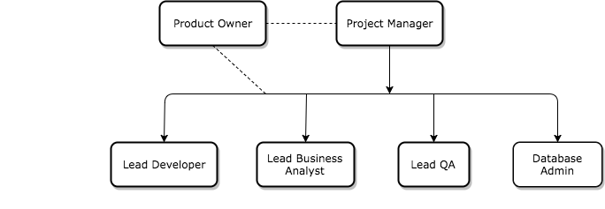

Team Members & Assigned Roles:

* Project Manager – Harrison Yang
* Product Owner – Darshan Venkata
* Lead Developer – Melba Louis Moro
* Business Analyst – Shaina Sunesara
* DBA – Artsiom Nalednikau
* QA Lead – TBD
* Tester – Tanvi Joshi

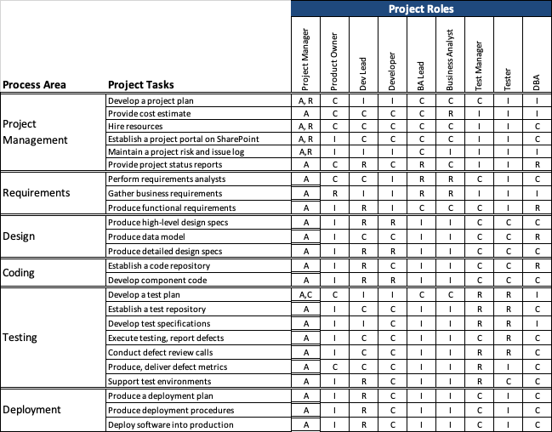

# Project Plan

This section will include a summary of the project plan, including a schedule of activities and resource requirements. Indicate, the team will follow the Agile development methodology.

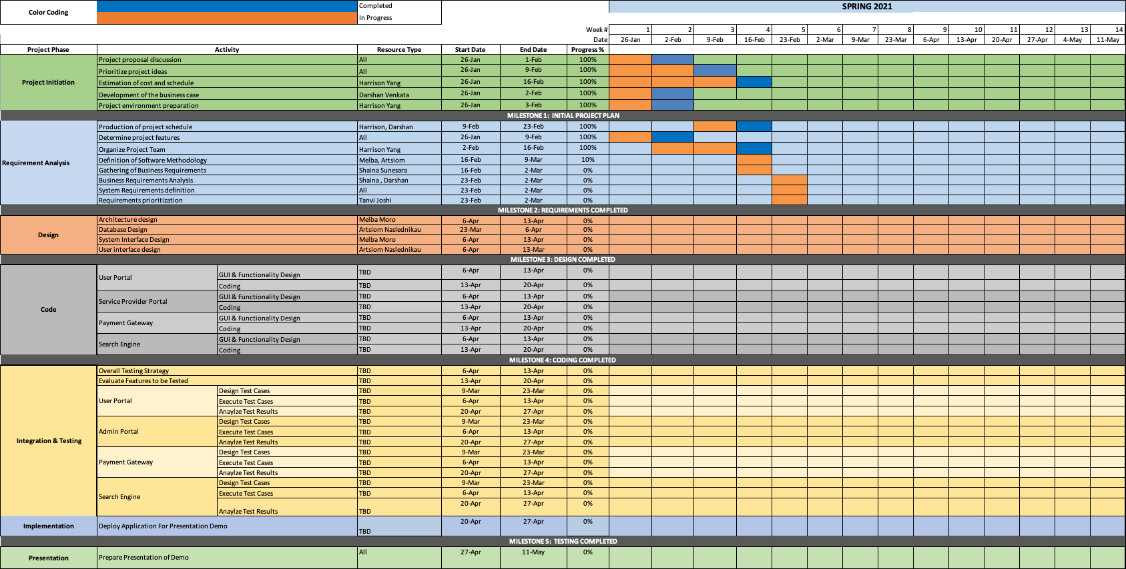

# Project Controls

* Project manager will conduct remote weekly meetings for project tasks and issue tracking.
* The Project Manager will generate regular reports and send it to the Professor.
* Communication will be done via Email and Slack with the project team.
* Google Drive will be used as a repository for official documentation.
* All source code will be uploaded to GitHub Repository.
* Project Management as a team is very important, meetings shall be held every week after class attendance is mandatory for the meetings. If there are meetings scheduled by the project manager each member must coordinate and attend the meeting at the set time. Meetings shall be held remotely so physical attendance is not necessary.
* If any member of the team faces any deadlock during the completion of the project it shall be notified on Slack and the whole team shall have responsibility for helping other members of the team.
* Slack shall be the primary way to communicate with team members using  instant messaging , if there are files that need to be shared it could be uploaded on the Official Google Drive or GitHub.
* The stakeholders shall be kept in the loop via E-mail, all relevant documentation shall be shared.
* The project manager shall be responsible for jotting down important information during the team meetings and shall report it to Professor Yuri Chernak along with the stakeholders.

# Communication Plan

This section will include how stakeholders will be communicated with during the project and how frequently. This should include a note on where to find the Communications Plan if you have one.

|  |  |  |  |
| --- | --- | --- | --- |
| **Stakeholder** | **Frequency** | **Type** | **Purpose** |
| **Harrison - Yang, Mr. Chang Q.: cy95850n@pace.edu** | THU FEB 11  THU APR 01 | Zoom Conference Call | Syncronization &  Cloud Documenation Revision |
| **Ms. Shaina: ss78990n@pace.edu** | THU FEB 18  THU APR 08 | Zoom Conference Call | Syncronization &  Cloud Documenation Revision |
| **Moro, Melba Louis: mm31798n@pace.edu** | THU FEB 25  THU APR 15 | Zoom Conference Call | Syncronization &  Cloud Documenation Revision |
| **an62556n@pace.edu** | THU MAR 04  THU APR 22 | Zoom Conference Call | Syncronization &  Cloud Documenation Revision |
| **dv39620n@pace.edu** | THU MAR 18  THU APR 29 | Zoom Conference Call | Syncronization &  Cloud Documenation Revision |
| **Joshi, Tanvi: tj66198n@pace.edu** | THU MAR 25  THU MAY 06 | Zoom Conference Call | Syncronization &  Cloud Documenation Revision |

Notes

* We could assume that each person is going to be responsible for documentation revision and synchronization up to last week of the first semester.
* We also assume that on the last week meetings could be going to be almost every day to fit the deadline and to have a chance to contribute if any necessity occurs.
* Google Drive Link: <https://drive.google.com/drive/folders/1CigXAZrWxcvPO_mRWpPC-uZlY6XGL9Ul>